PERSONAL PROFILE

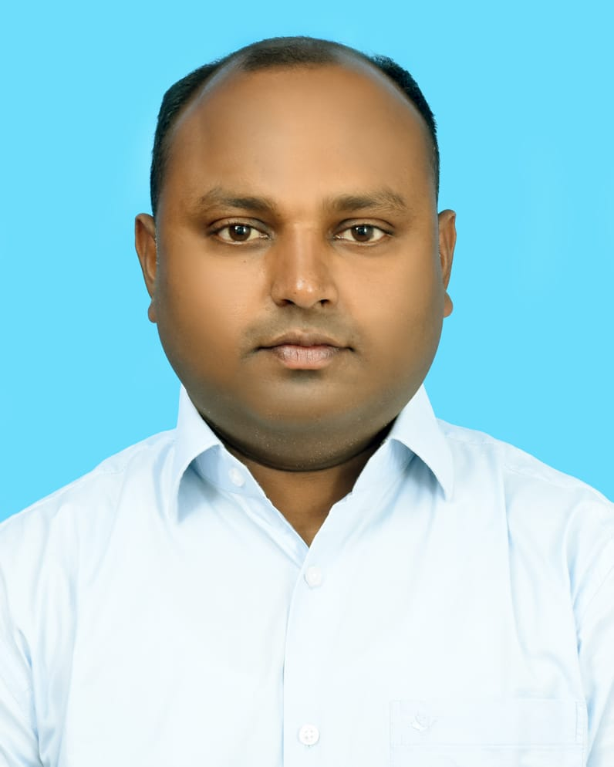
Recent Photograph

Name: - ASIN MD ANSARI

Designation: - ASSISTANT PROFESSOR IN HISTORY, WBES

Date of Birth:-28/11/1984

Educational Qualification:-
Sl No. | Degree obtain  (Abbreviation of the degree) | College/ university from which the degree was obtained | Year of Passing
1. | BA (HONOURS IN HISTORY) | UNIVERSITY OF NORTH BENGAL | 2007
2. | MA (HISTORY) | UNIVERSITY OF NORTH BENGAL | 2009
3. | M.Phil. | UNIVERSITY OF NORTH BENGAL | 2016

Permanent Address:- VILL – RABINDRA SARANI, PO.- KADAMTALA, PS- MATIGARA, DT. – DARJEELING, PIN NO - 734011

Contact Number: - 7477856896

E-mail:- asin.ansari84@gmail.com

Date of joining (Service):- 11/12/2015

Specialization: - MEDIEVAL INDIAN HISTORY

Area of Interest: - ECONOMIC HISTORY

Faculty Development Programme:-
Sl No. | Year | Name of Programme Participated (OP/ RC/FDP/Summer School/FEP/Others) | Organized By
1. | 2017 | Short term Course on Research Methodology | UGC-HRDC, ACADEMIC STAFF COLLEGE NBU
2. | 2019 | 36th Orientation Programme | UGC-HRDC, ACADEMIC STAFF COLLEGE NBU
3. | 2020 | Refresher Course in History | UGC-HRDC, ACADEMIC STAFF COLLEGE NBU
4. | 2023 | Online Refresher Course On Artificial Intelligence, Cyber Security & Information Science( Subject area: All disciplines) | UGC-HRDC, ACADEMIC STAFF COLLEGE NBU

International:-
Sl No. | Year of Publication | TITLE | Journal Name | ISSN/ ISBN | Published By
1. | 2017 | Environmental Ethics in Islam | International Journal of Integrated Research and Development | ISSN:  2278-8670 | Society for Journal of Integrated Research and Development of India
2. | 2019 | Mughals in the Bengal Frontier: A Case Study of Pargana Bhagalpur | International Journal of Integrated Research and Development Development | ISSN: 2278-8670 | Society for Journal of Integrated Research and Development of India

Paper Presentation: Conferences/Seminars /Symposia /Workshops:-
Sl no. | Year | Title | Organized by | International  /National  / State Level
1. | 2016 | Post-Partition Migration of The Refugees to North Bengal From 1947-1970: Problems and Perspective | Department of History, University of North Bengal | National
2. | 2016 | Socio-Economic Condition of the Tribes of Jalpaiguri District | Department of History, Gyan Jyoti College, Dagapur, Siliguri | National
3. | 2016 | Recent Developments in Eco-Tourism in the Hills of Kalimpong | Government College, Fagu, Darjeeling- 735231, West Bengal | National
4. | 2018 | Formation of the Tripura Tribal Areas Autonomous District Council: A study of Political Development from 1947-1985 | Government College, Fagu, Darjeeling- 735231, West Bengal | National
5. | 2020 | Local Nationalism and Early Mughal Occupation in Bengal: The Case Study of Bara Bhuiyas | Institute for Social Development and Research, Gari Hotwar, Ranchi- 835217( Jharkhand) | National

